**Ashish_RQuiz 5**

1. Write a Ruby program that Reads from sample.txt (contains plain text) and creates a new config file called text.cfg

Ans:

file = File.new("testing.txt", "w")

file = File.open("testing.txt", "r")

file = File.new("text.config", "w")

file.close

gets

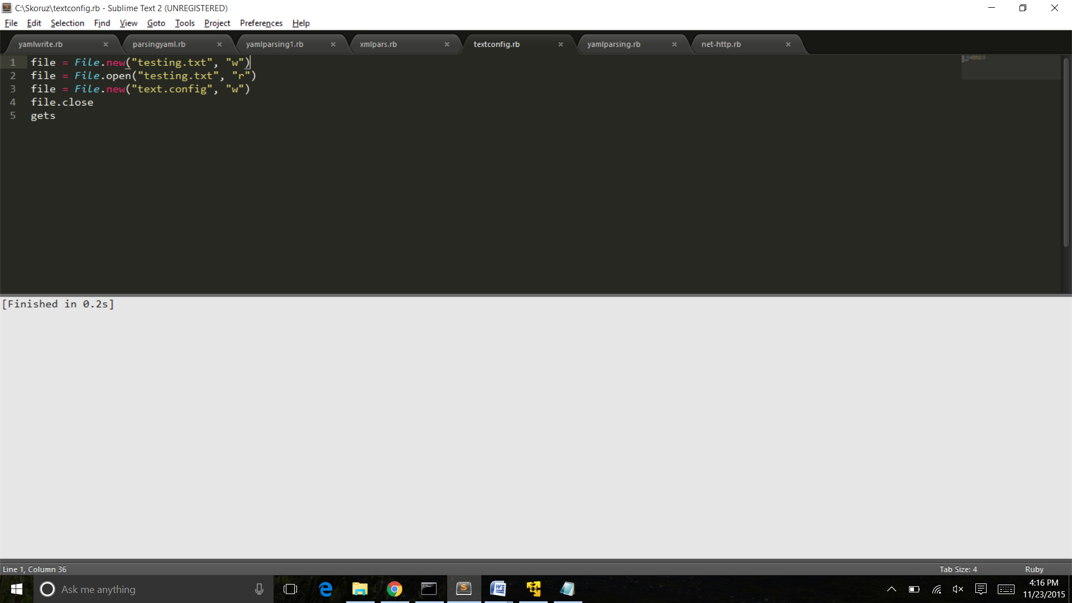

2.Write a sample ruby program that uses XML and JSON parsing

Ans :

require 'json'

my_hash = JSON.parse('{"hello": "bye"}')

puts my_hash["hello"]

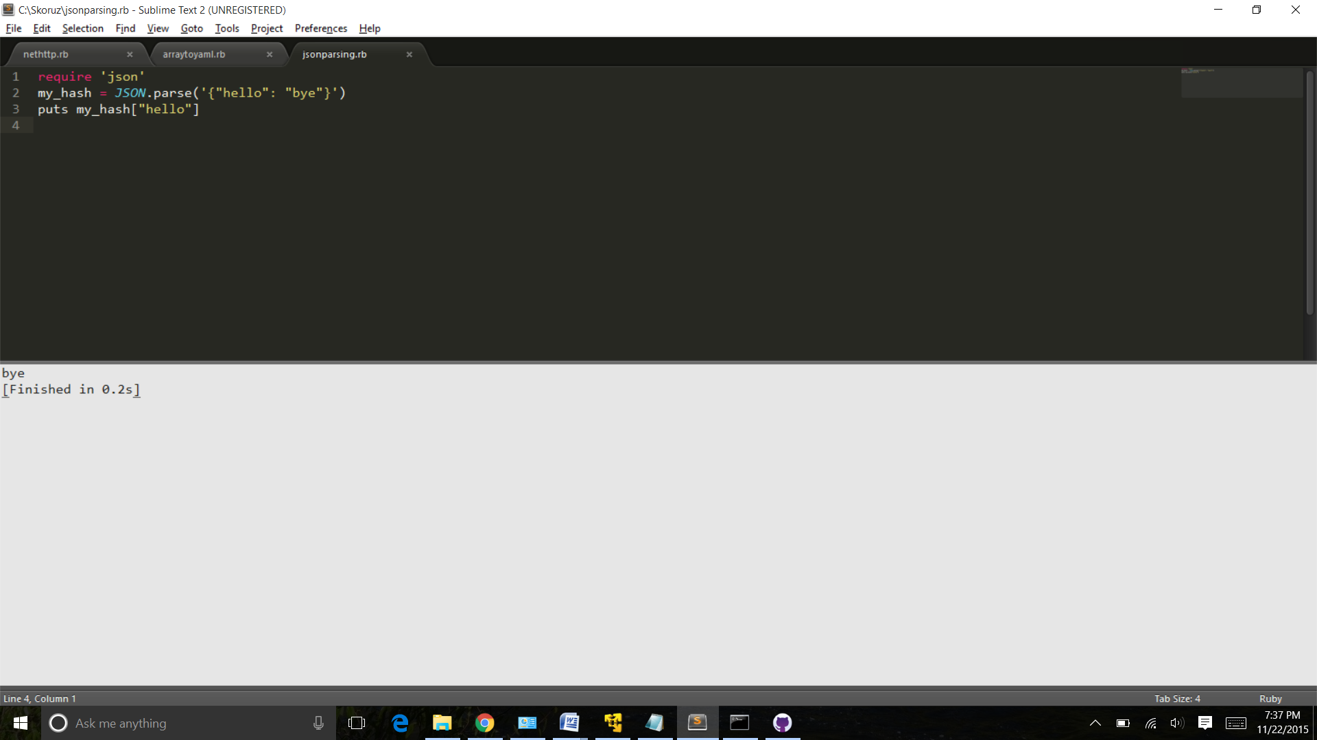

require 'rexml/document'

include REXML

xmlfile = File.new("test.xml")

puts xmldoc = Document.new(xmlfile)

gets

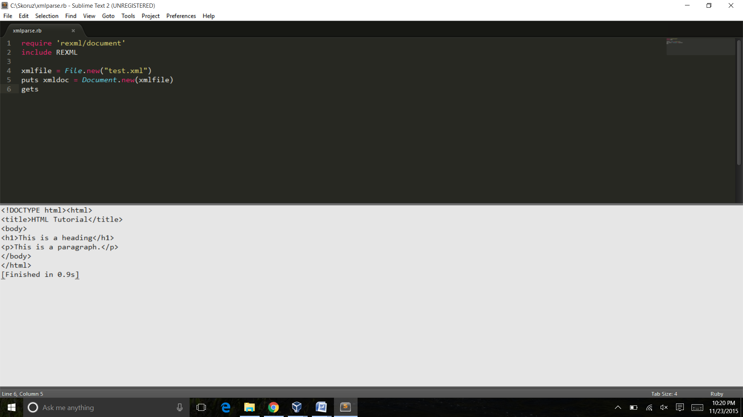

3. Write a sample program that converts a string or array to YAML ?

Ans :

require 'yaml'

names = ["ABC", "BCD", "XYZ"]

puts names.to_yaml

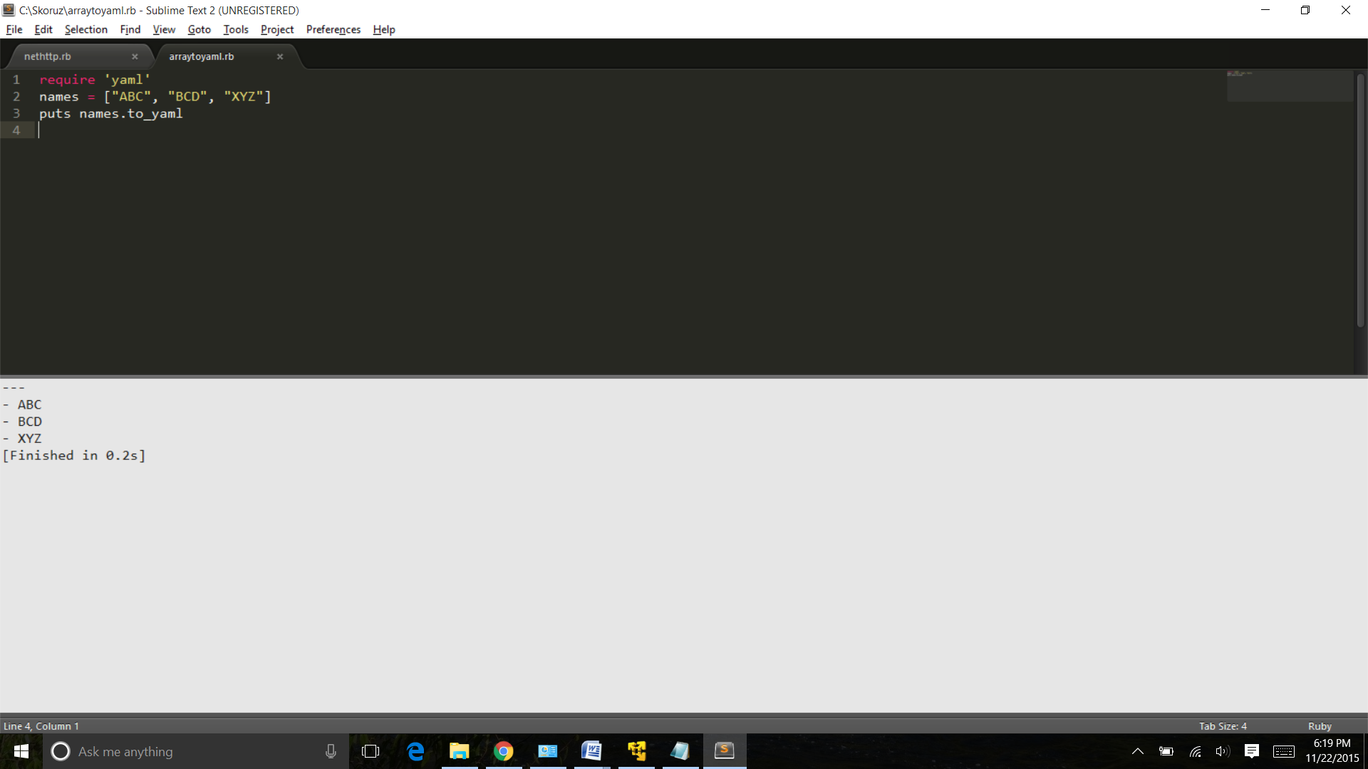

4.Write a Program that converts string to YAML and shows difference between different ways of YAML conversion.

Ans :

require 'yaml'

yaml1 = 'ashish'

puts yaml1.to_yaml

yaml2 = 'ashish'

yaml2 = YAML::dump(yaml2)

puts yaml2

gets

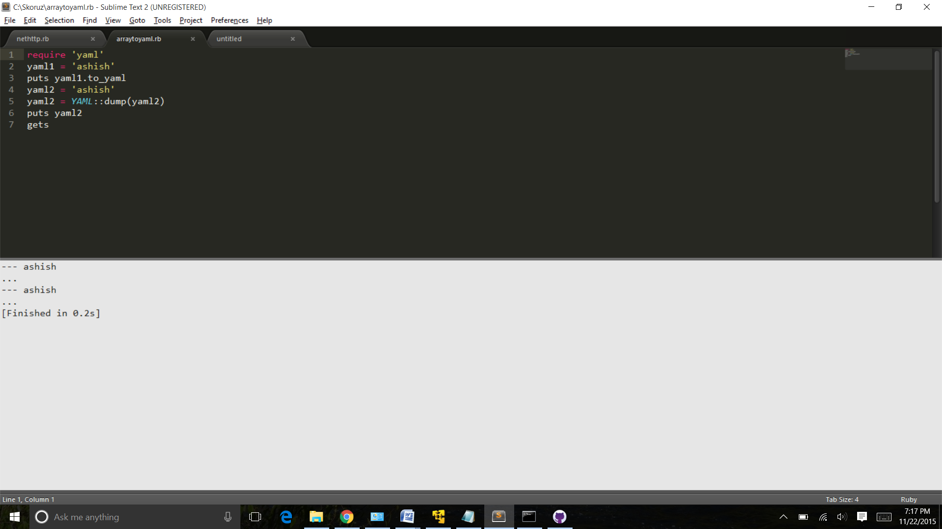

5. Write a sample ruby program for YAML File  and try to modify YAML file

Ans :

require 'yaml' # Built in, no gem required

d = YAML::load_file('/Skoruz/test.yml') #Load

puts "Original file,#{d}"

d["a"]=100 #Modify

File.open('/Skoruz/test.yml', 'w') {|f| f.write d.to_yaml } #Store

puts "Modified File ,#{d}"

file.close

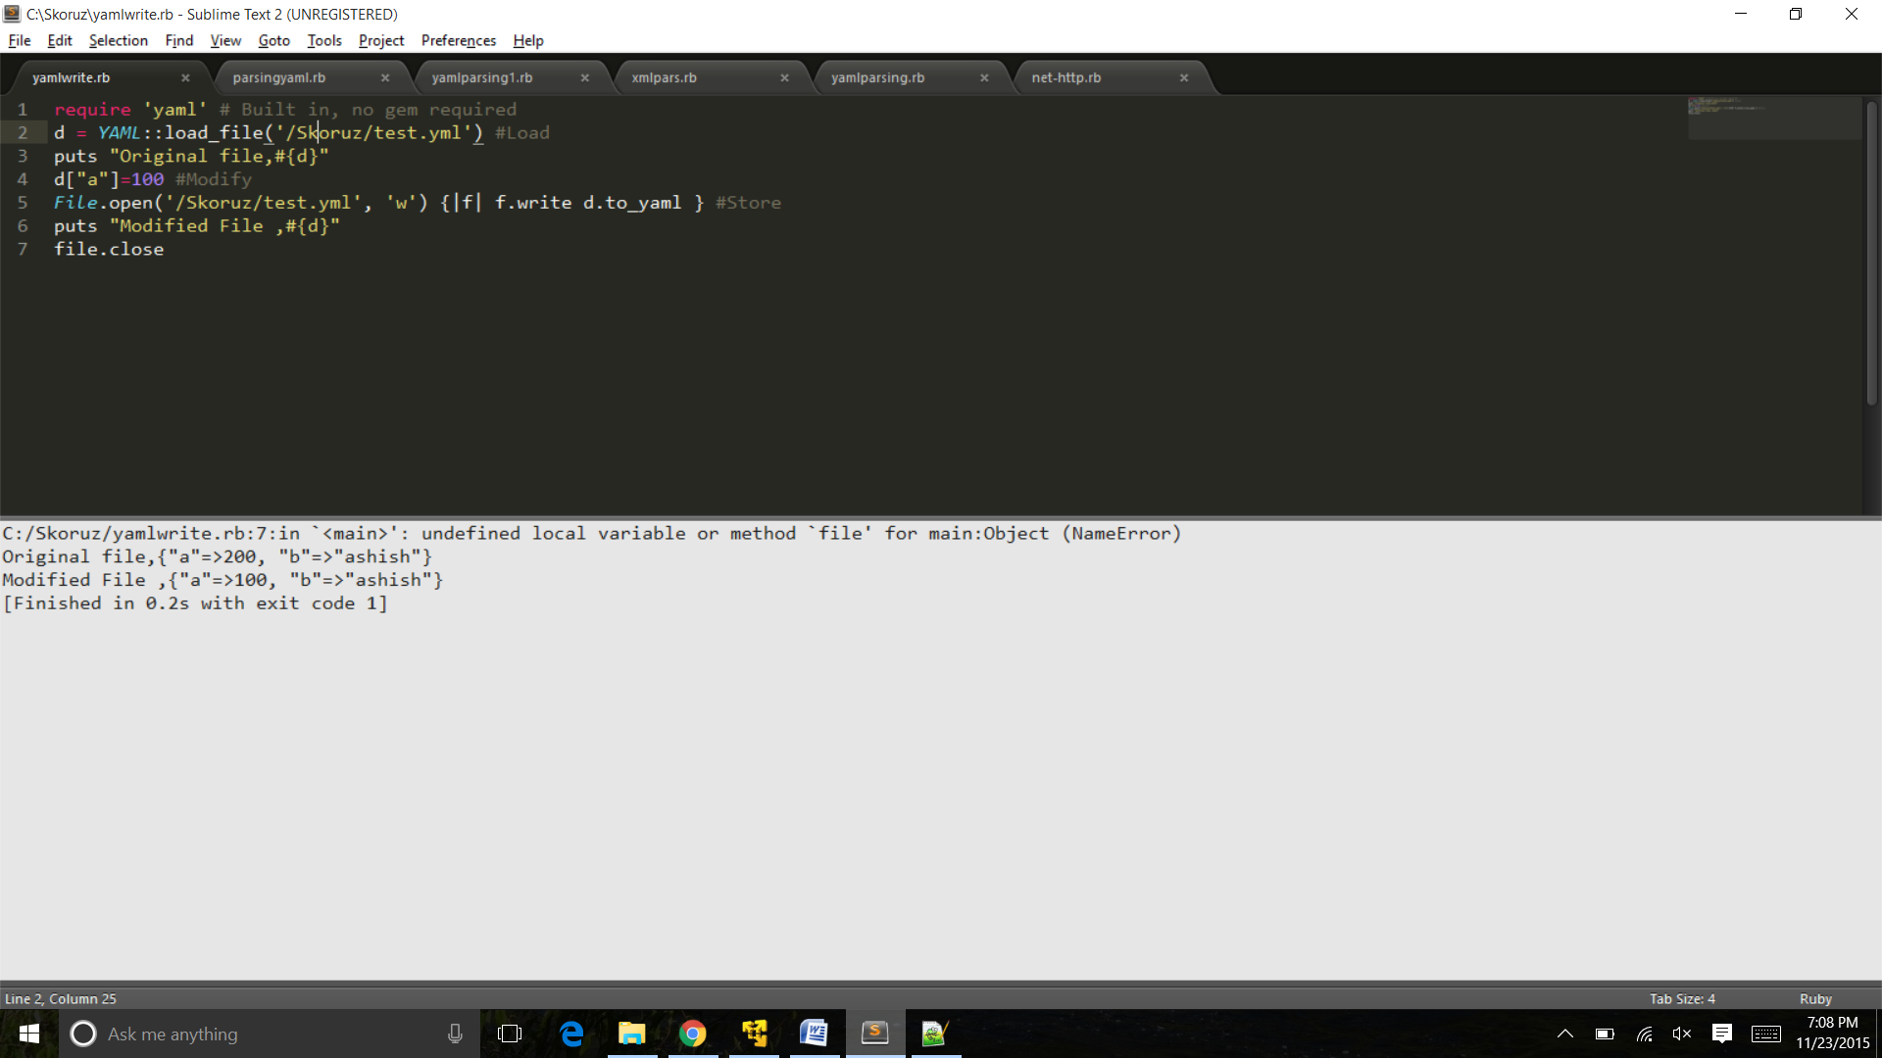

6.Write a Sample ruby program for Parsing YAML

Ans :

require 'yaml'

puts YAML.load("--- ashish")

puts YAML.dump("ashish")

#{ :a => 'b'}.to_yaml

gets

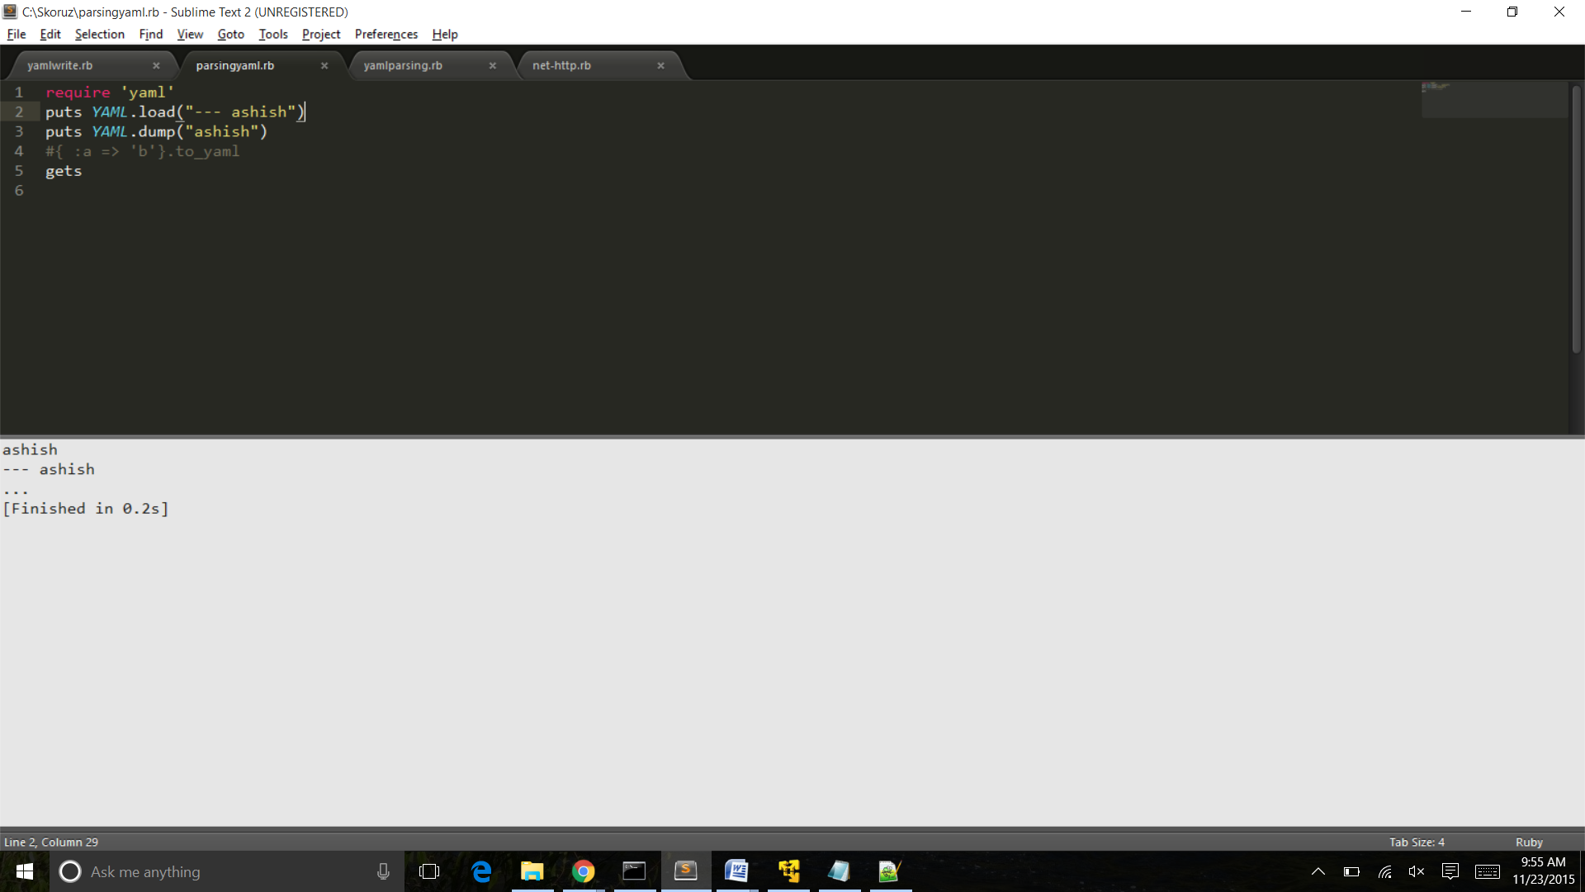

7.Write a program using YAML which checks for user id and password

8. Write a sample program that connects to database and create a table in database

Ans: #!/usr/bin/ruby  
  
require 'mysql'  
  
begin  
      
    con = Mysql.new 'localhost', 'ashish', 'password', 'TestDB'  
     
    con.query("CREATE TABLE   
       Students (Id INT PRIMARY KEY AUTO_INCREMENT, Name VARCHAR(25))")  
    con.query("INSERT INTO Students(Name) VALUES('Jack London')")  
    con.query("INSERT INTO Students(Name) VALUES('Honore de Balzac')")  
    con.query("INSERT INTO Students(Name) VALUES('Lion Feuchtwanger')")  
    con.query("INSERT INTO Students(Name) VALUES('Emile Zola')")  
    con.query("INSERT INTO Students(Name) VALUES('Truman Capote')")     
      
rescue Mysql::Error => e  
    puts e.errno  
    puts e.error  
      
ensure  
   con.close if con  
end

9.Write a program that creates a connection to an HTTP server. Use net/http

Ans:

require "net/http"

require "uri"

uri = URI.parse("http://google.com/")

# Shortcut

response = Net::HTTP.get_response(uri)

# Will print response.body

Net::HTTP.get_print(uri)

# Full

http = Net::HTTP.new(uri.host, uri.port)

response = http.request(Net::HTTP::Get.new(uri.request_uri))

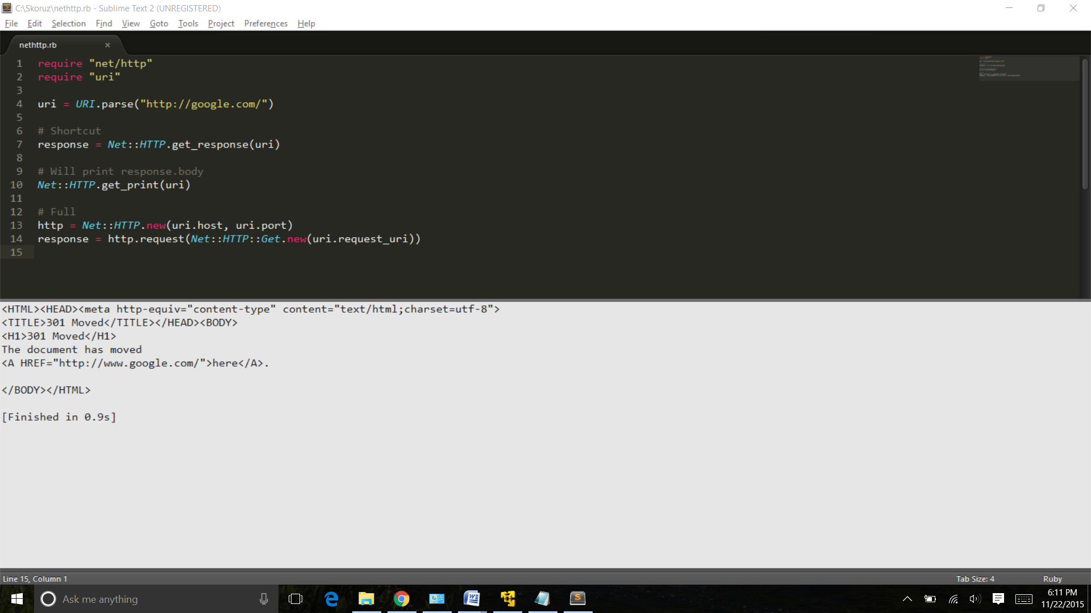

10.Write another sample program that uses NET::HTTPS